**MPO 563 Exam -- Review material. Exam is on April 4.**

**After spring break 2017**

We have learned some low-level “principles”, multi-principle “processes” and multi-process “phenomena” of mesoscale and convective meteorology. Time to tamp that material down with a test! Then we can talk increasingly about complex real events, but with some pilings rooted in that educated perspective.

Here are questions I think are reasonable to ask. You should try to ponder and address them all, and be ready to say something if these or very similar ones appear on the exam. In fact I will probably just save this document and cut a lot and add some numbering and scoring to write the exam. So really, you should aim to grok all this. Bring questions Thursday for the Tuesday test.

**Part 1: My stuff, and our Testables Google Doc:**

1. How few variables can suffice to describe the state of an air+vapor parcel? Write down at least sets of variables that contain the same information, which could be converted from one set to another, but are useful in different contexts:

a. Measured: by what instruments?

b. Conserved: in what processes? (vertical motion without condensation, or with)

c. Fundamental: what does gravity acts on? What does latent heating depend on?

2. Write the first law of thermodynamics for a parcel of ideal gas, dT/dt = 2 terms. Explain *two different ways* we can recombine things to get it in the form d(something)/dt = 1 term. Hint: something = entropy or potential temperature, or dry static energy. Derive the dry adiabatic lapse rate from the concept d(something)/dt=0, so that something is the same at all altitudes in an adiabatic well-mixed layer where parcels are interchanging freely.

3. Why is the troposphere convecting? What state do convecting fluids tend toward (that is, what is the end state toward which the process of convection drives things?). Why does potential temperature (or dry static energy) never decrease with height?

4. What is the most important equation governing fluid flow? (Hint: it makes a fluid different from a set of billiard balls). What is the second most important equation? (Hint: it involves gravity).

5. What is a *flux*? What are its units? Using the units as a guide, write a symbol or product of symbols that we use for (a) volume flux, for (b) mass flux, (c) moisture flux, (d) momentum flux. Hint: these symbols (physical quantities) may have other interpretations too, so stick close to the units as the guide to the meaning of flux.

6. Write our entire set of Boussinesq equations in Cartesian coordinates. Label them according to the physical principles they represent: F=ma, 1st law, mass continuity.

a. Write them in scalar form (u,v,w) with the total derivatives d/dt(_) = sources and sinks

b. Write them in scalar form (u,v,w) with partial derivatives (you may use subscripts), using *advective* form for the transport terms

c. Write them “ “ “ , using *flux* form for the transport terms

d. Write them using vector form for the flow **V** = {u,v,w} and ∇ for the del operator.

7. How are b and π related to our usual thermodynamic variables T, q, r, p? Explain.

8. What is the job of pressure perturbations? Write it mathematically so that you get an equation for π = πb + πdyn = ∇-2( b-related-term + divergence-of-inertia), where “inertia” is the blurry household word for the advection of momentum.

9. Why is the inverse Laplacian like a smoother times a negative sign?

10. Show that the source of kinetic energy, integrated over a whole mass of fluid like the entire atmopshere, ∂/∂t [KE] = [bw] where [] indicates the average over the whole mass

11. Thermodynamic profiles: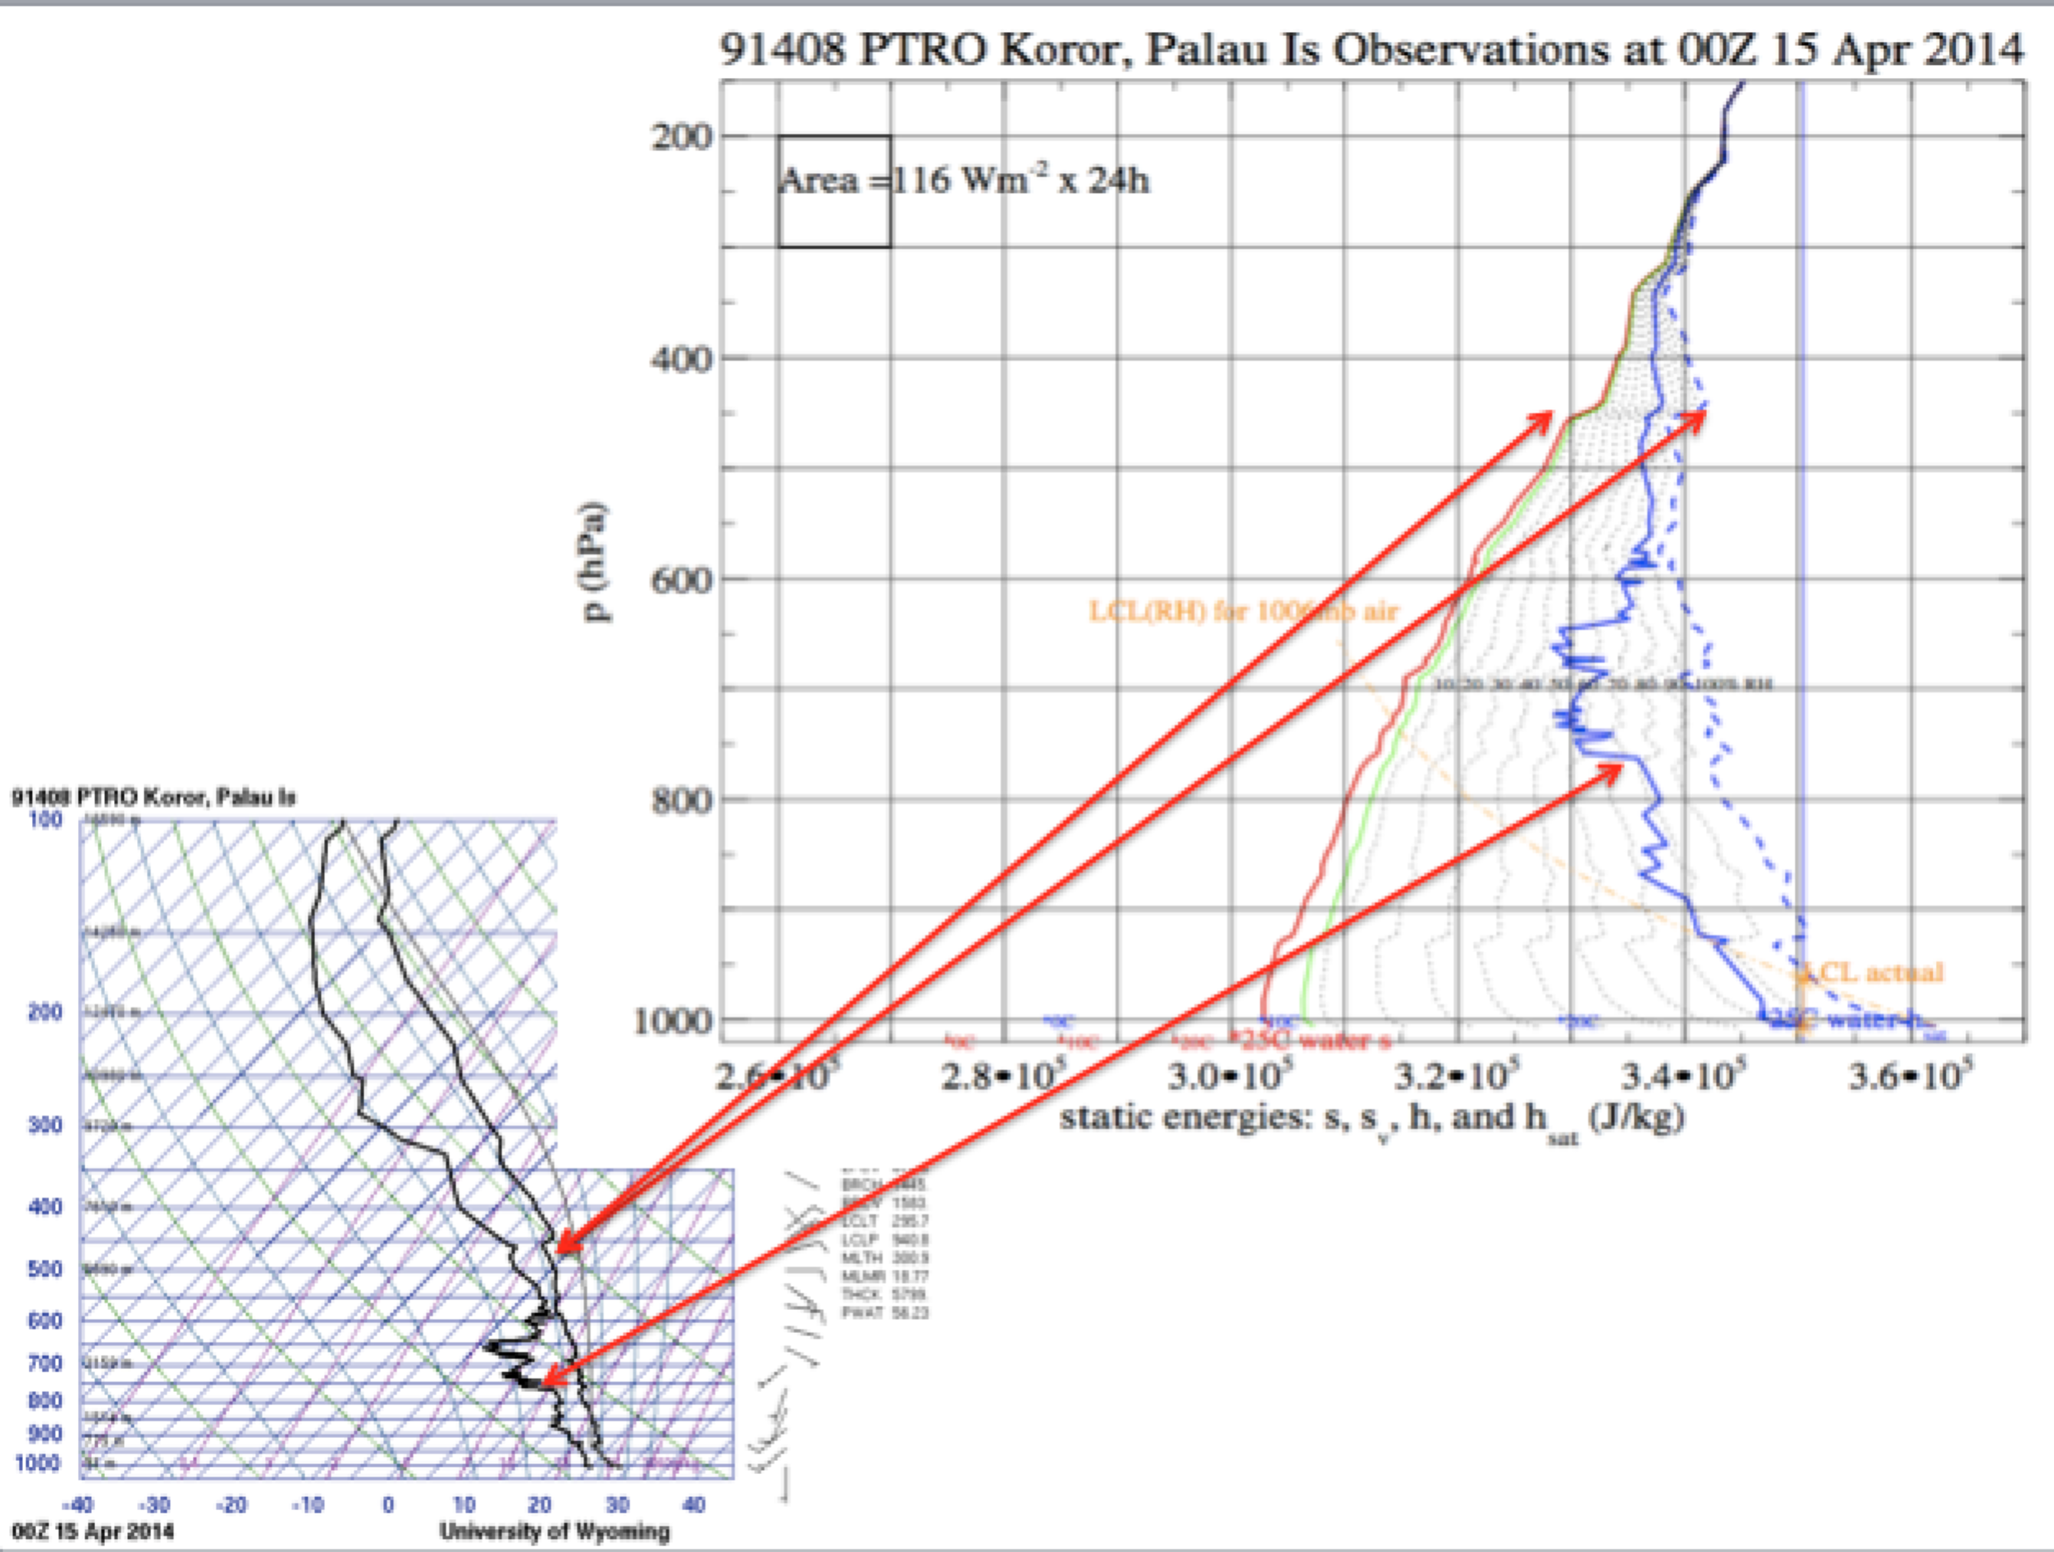

a. What are the 3 curves on this conserved-variables plot? Names, definitions.

b. Sketch the T dependence of qsat(T,p) as used for the rightmost curve. It is curved.

12. On a diagram like the above,

a. sketch the 3 curves that would result from the effects of a uniform radiative cooling of -1.5 K/d acting from 1000-200 hPa for a few days, with no other effects (advection or other processes). Hint: 1.5 K/d is about 150 Wm-2, notice the guide to the meaning of area in the upper left of the diagram.

b. sketch the effects on the 3 curves due to 232 Wm-2 of surface fluxes acting for 12 hours (one square of energy addition).

i. if the flux is 100% sensible, 0% latent, and applies over a 100 hPa well mixed PBL?

ii. if the flux is 100% latent, 0% sensible, and applies over a 50 hPa well mixed PBL?

iii. Which of these scenarios destabilizes the atmosphere more, in the sense of making lifted parcels from near the surface have more buoyancy when lifted to midlevels?

**Ch1: Consider these diagrams to categorize scales:**

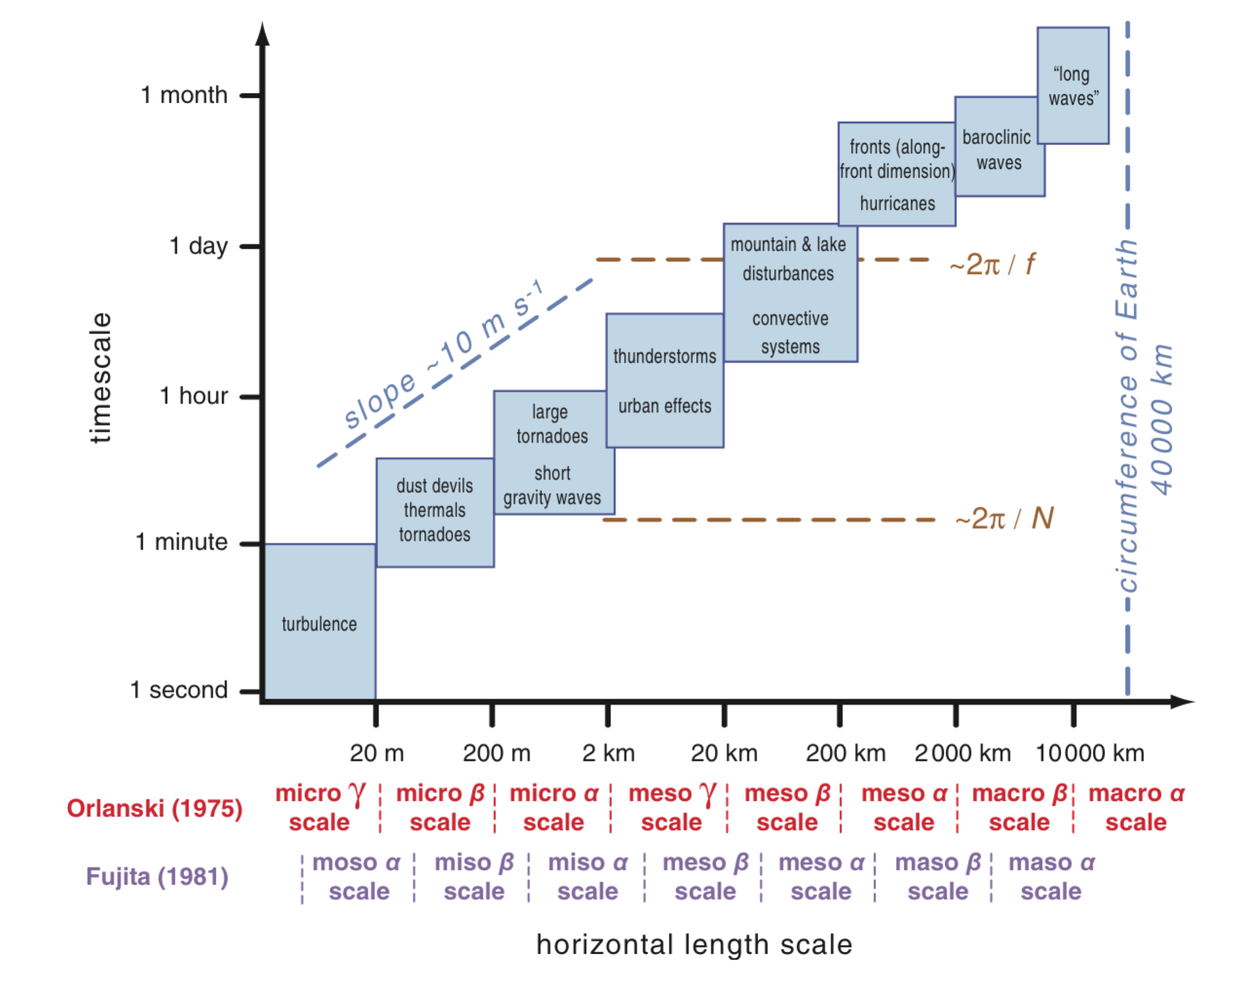

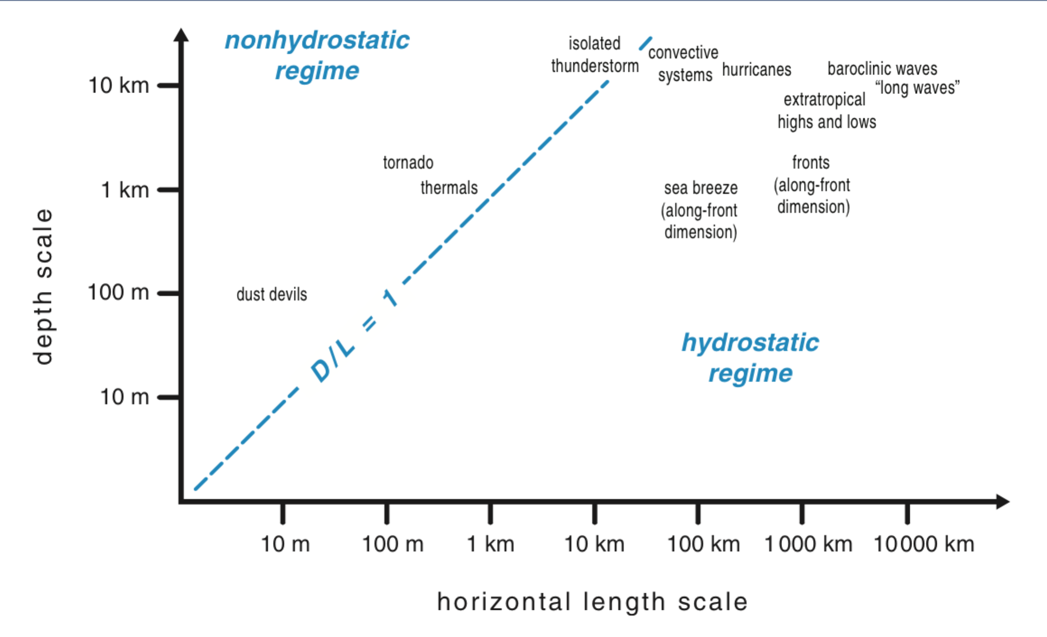

13. On these diagrams, indicate where the following phenomena fall:

Atm. Space scales:

Circumference of Earth 40,000 km (original definition of meter)

Depth of troposphere 10-15 km

Depth of PBL ~1km or a few

Rossby radius of deformation c/f 🡪 few hundred km

(c is wave speed ~50m/s; Coriolis f=2W sin(lat)= 1.0 x 10-4 s-1 at 40N)

Brunt-Vaisala period (2p/N) in a moist adiabat (tropical sounding): 10 min

Inertial period (2p/f), Earth rotation time: 24h at 30 degrees latitude

Daily solar heating cycle: 24h

Velocity scales:

Deep gravity wave in moist adiabatic sounding: 50 m/s

Typical winds on Earth 10 m/s

14. Add these phenomena meaningfully in the diagram space:

1. Sound waves have a speed of about 300 m/s. Indicate this speed as a line slope. The volcano Krakatoa in 1889 excited an external atmospheric wave traveling about 300 m/s and circling the globe very rapidly (in how long?). Indicate where that wave would fall on the scale diagrams.
2. Seasonal microclimates can occur when a topographic feature or urban center (say 10km in scale) induces local PBL circulations that affect conditions– but only in the summer (or perhaps only in the winter). Where does that phenomenon fall on the diagrams?
3. The Rossby Radius of Deformation (R = c/f) is the distance a gravity wave of speed c can travel in an Earth rotation related timescale 1/f. For larger space and time scales, all flows can be viewed as geostrophically balanced. Indicate that geostrophic corner on the length scale – time scale diagram above, for a deep gravity mode (same-signed T’ through the whole troposphere) with c=50 m/s.
4. Suppose river flow has a mean speed across the landscape of perhaps 1 m/s (meanders and friction slow it down). Indicate this speed on the space-time scale diagram above. Indicate with a dot the time scale for a pulse of rain at the top of a watershed to reach the coast, say 1000km downstream.
5. Where do PBL cold air outbreaks down the Florida peninsula sit on the diagrams above?

15. **Hodographs**: wind shear, thermal advection, and a vector space for storm motion.

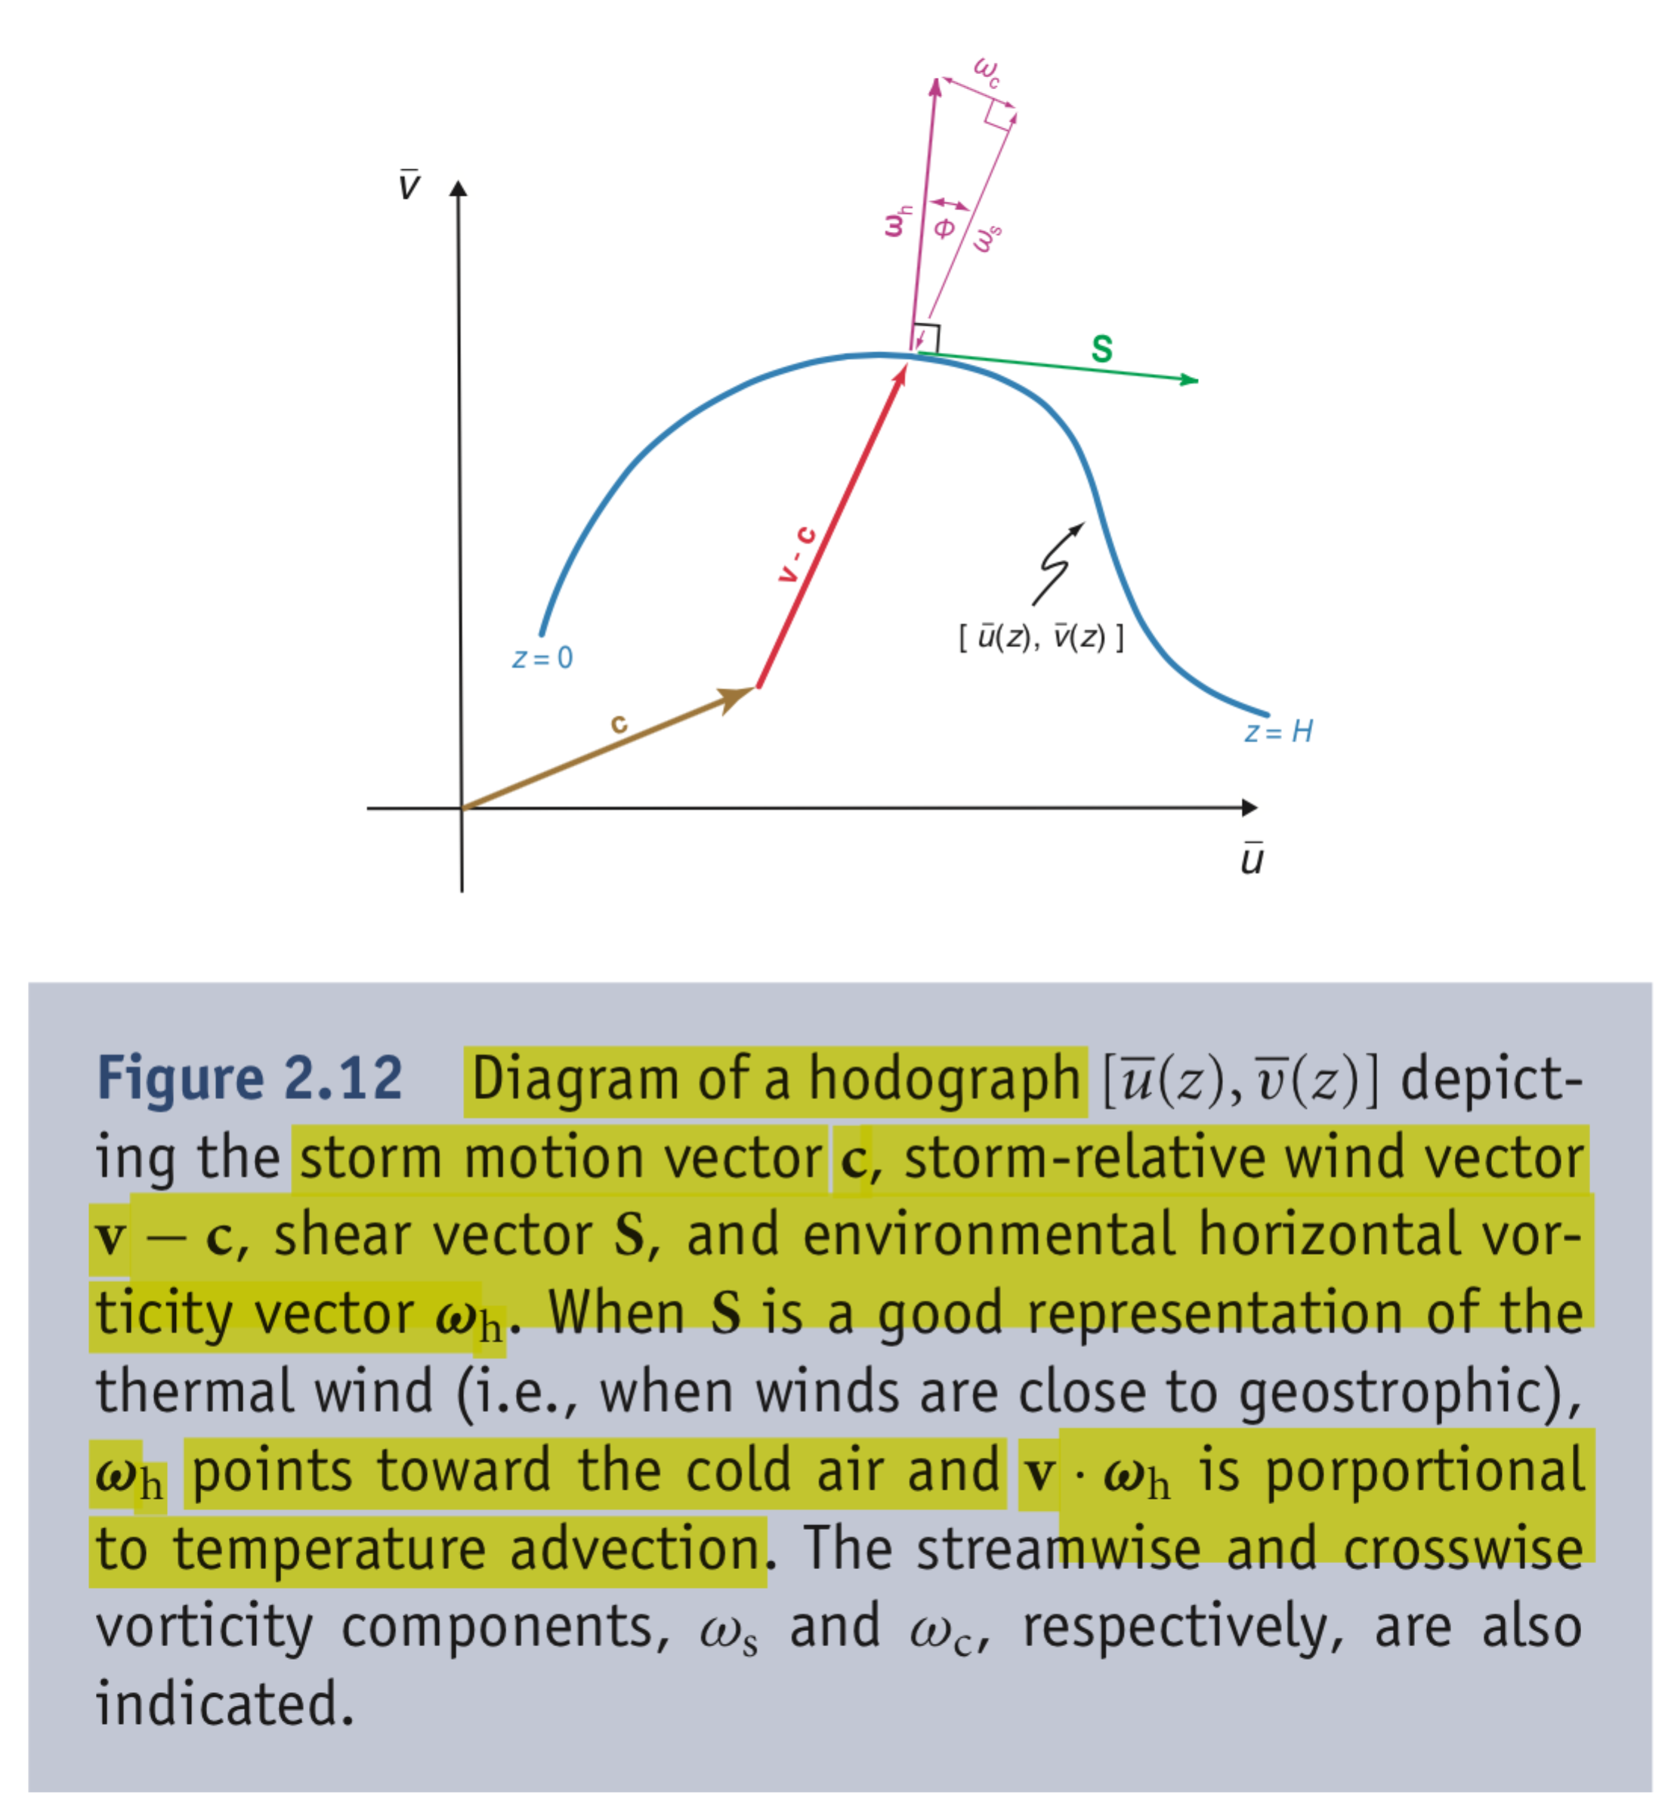

You should understand all the meanings of a hodograph as in the figure above. Then answer these questions:

15. Sketch a hodograph for a “back-building” type of flash fllod event. Remember, it involves a lot of rain at one location, meaning a stationary storm speed, even as individual cells (which are advected by a layer-averaged mean flow, roughly speaking) move to the east. Indicate the low-level storm-relative inflow that helps build new cells on the west side, making the net storm motion nearly zero.

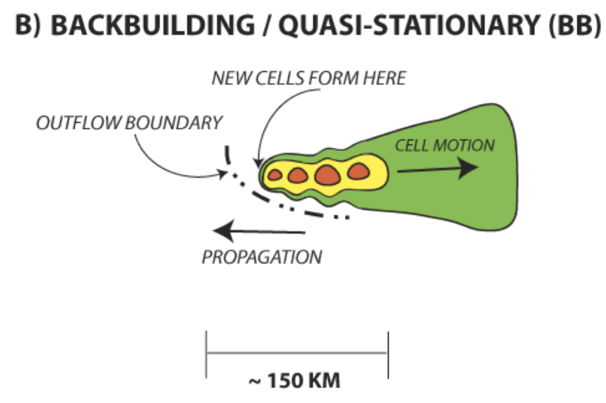

16. Sketch a hodograph for this TL/AS form of flash flood producing storm. Notice that the system is on the cool side of a surface front, recalling that fronts are drawn at the warm edge of a frontal region with a gradient (so this occurs in a southward T gradient), remembering the thermal wind relation. Notice also the words about shear and about cell motion. Make sure your hodograph is consistent with all those constraints and conditions.

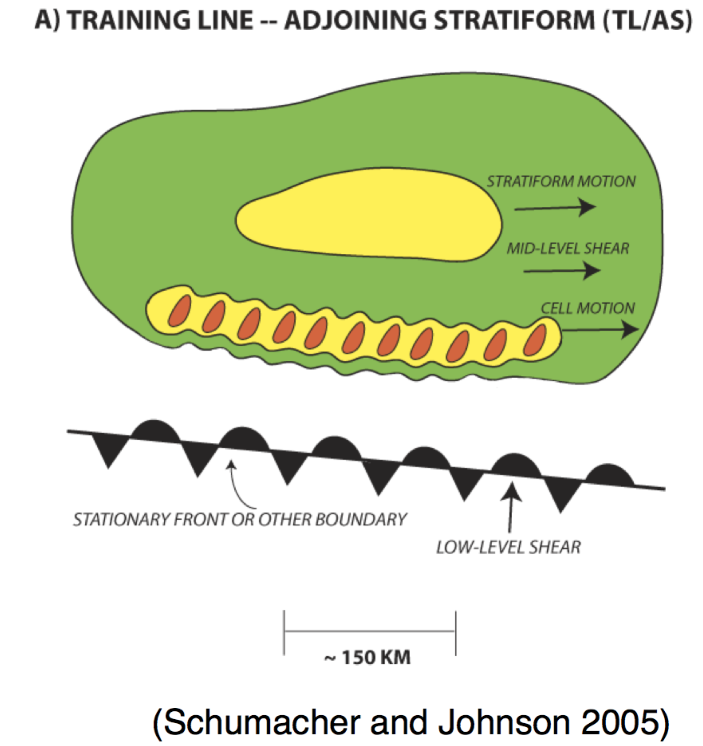

***17. Planetary boundary layer and turbulence: Fig. 4.1 of book***

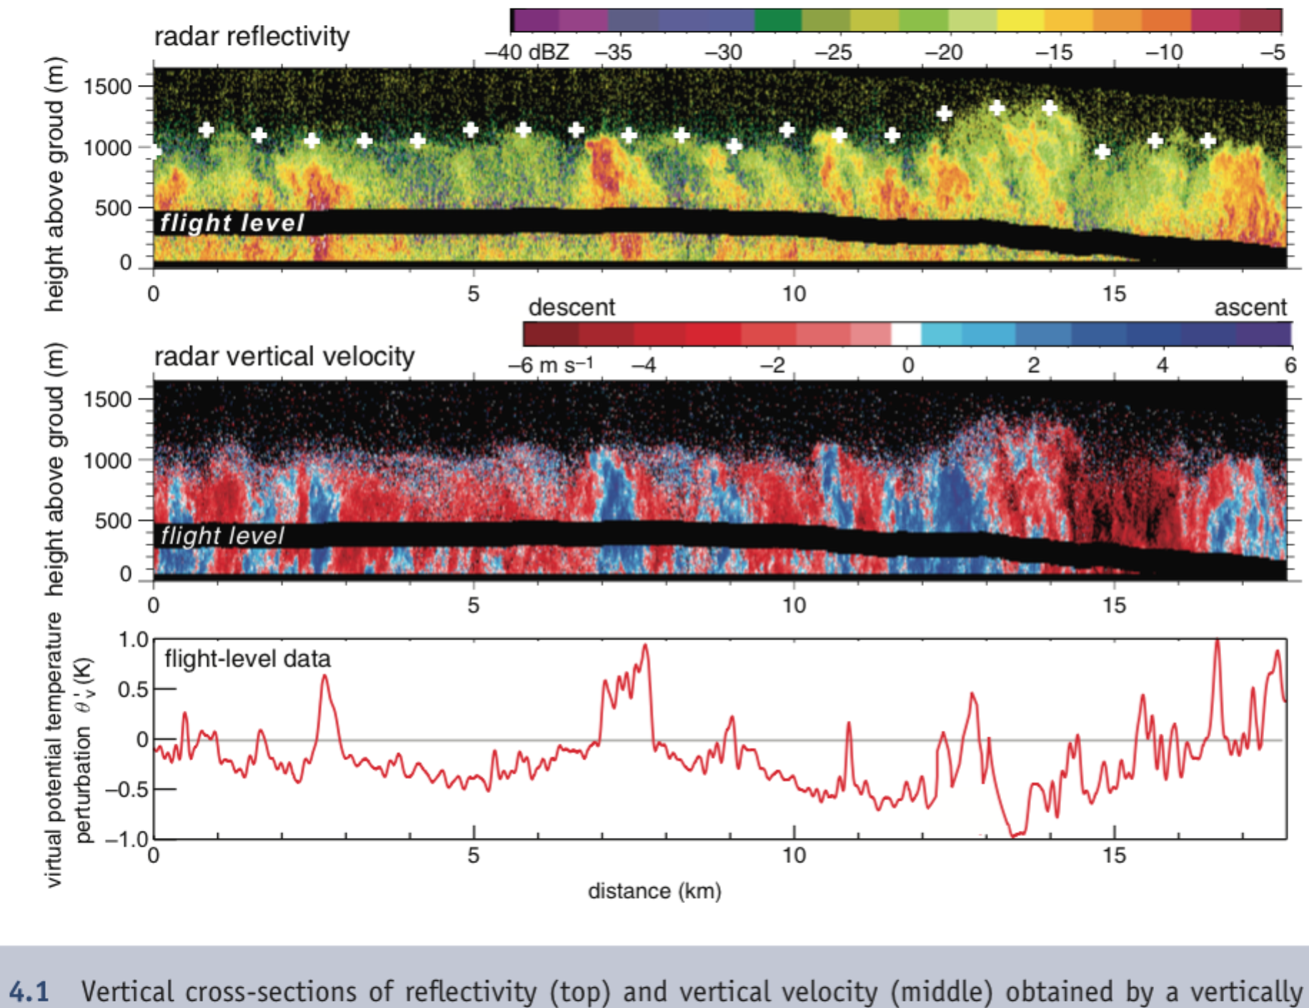

1. Indicate the main regions with T’ >0 (or strictly, qv’ >0), and with w’ >0, where the prime is a *deviation from the horizontal average*.
2. Sketch under Fig. 4.1 the indefinite integral (the cumulative flux from x=0), 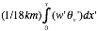. Notice that the value at the right hand edge of this sketch x=18 km is the total turbulent flux. Which contributes more to the turbulent eddy heat flux, hot updrafts or cool downdrafts? What does this imply about the convection? (bottom-up, heated from below? or top-down, cooled from above?)
3. Show that the heat flux, in the First Law of Thermodynamics which governs  is Cpr  (That is, show that the units are then Joules per square meter per second). Estimate the approximate value of the total heat flux, in Wm-2, from the data above.
4. Recall that buoyancy flux wb is the source term in a KE equation. Since buoyancy b = g v’/o, convert 3. into an estimate of how many J/kg ***of turbulent KE*** would be created by 3 hours of the thermally direct turbulence shown in the figure. If that TKE is equally stored in the u, v, and w wind components, what is the typical wind speed of the turbulence created by 3 hours of this sort of convection?

18. ***Ageostrophic wind and the low level jet:*** 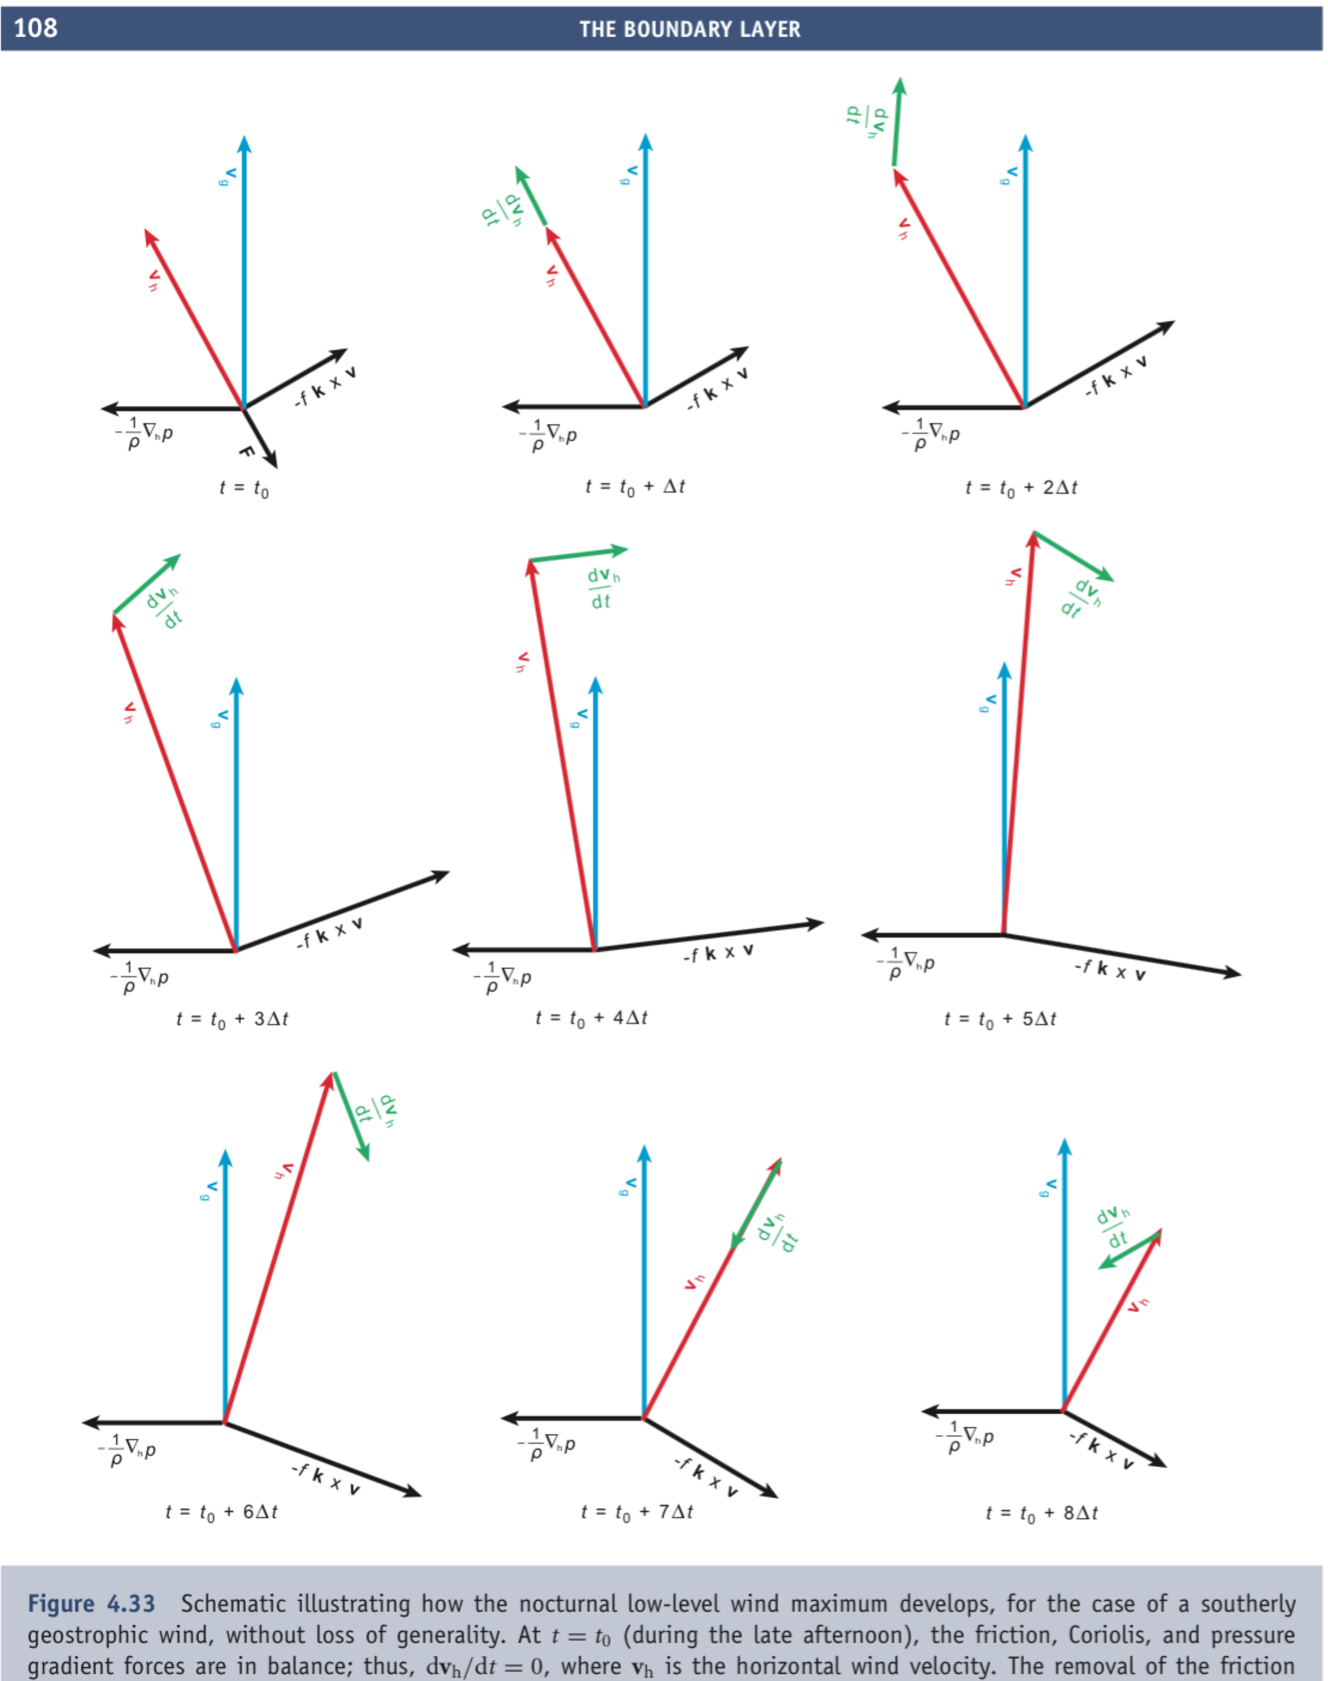

1. Explain the force balance in the first panel.
2. Show from our Boussinesq equations that  and  for frictionless flow (F=G=0) with the nonlinear advection terms neglected.
3. Show how the rotation of the green va vector around the tip of the (assumed constant) blue vg vector is governed by the above equation.
4. What is the inertial period 2/f, at latitudes of 0, 30N, 45N, 90N? Where on Earth besides the US Gulf coast is the ‘magic’ 30 degree latitude line resonant with diurnal thermal forcing (which has a 24 hour period)?

***19. Pressure perturbations:***

Recall this interpretive form for p’ (and recall  = p’/0) in our Boussinesq equation set. Note that **** here is the vector vorticity:

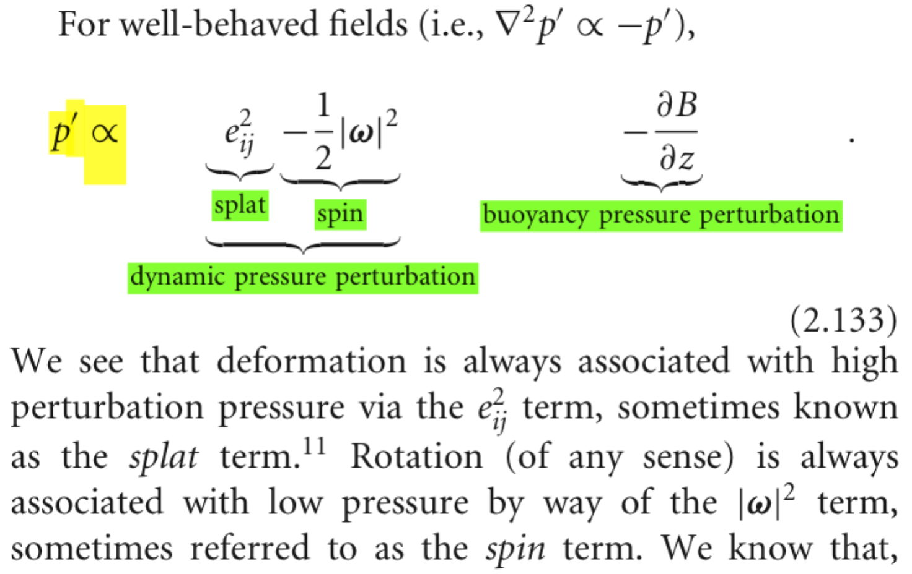

a. Based on the interpretation above, identify the signature of the 3 components of p’ (the 3 terms in its equation) in the diagrams below:

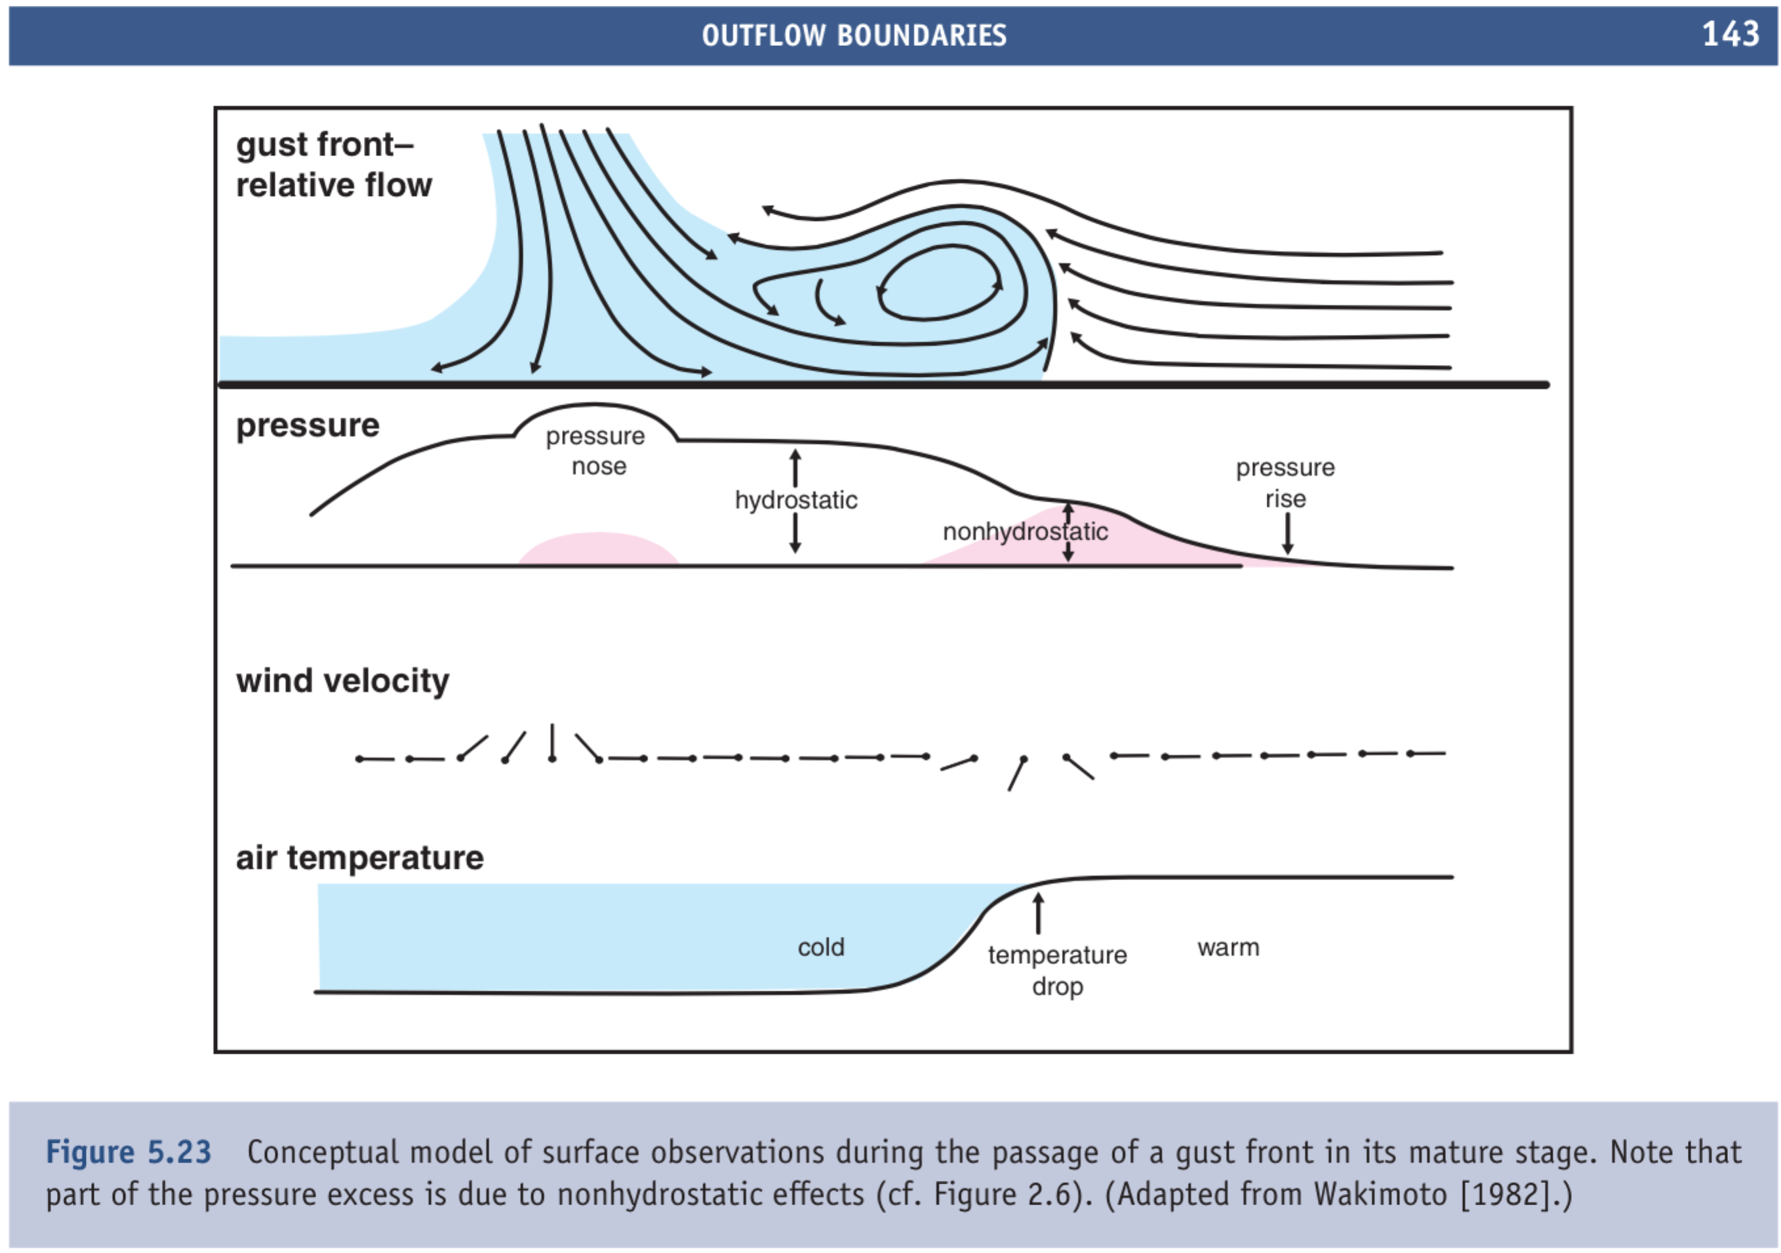

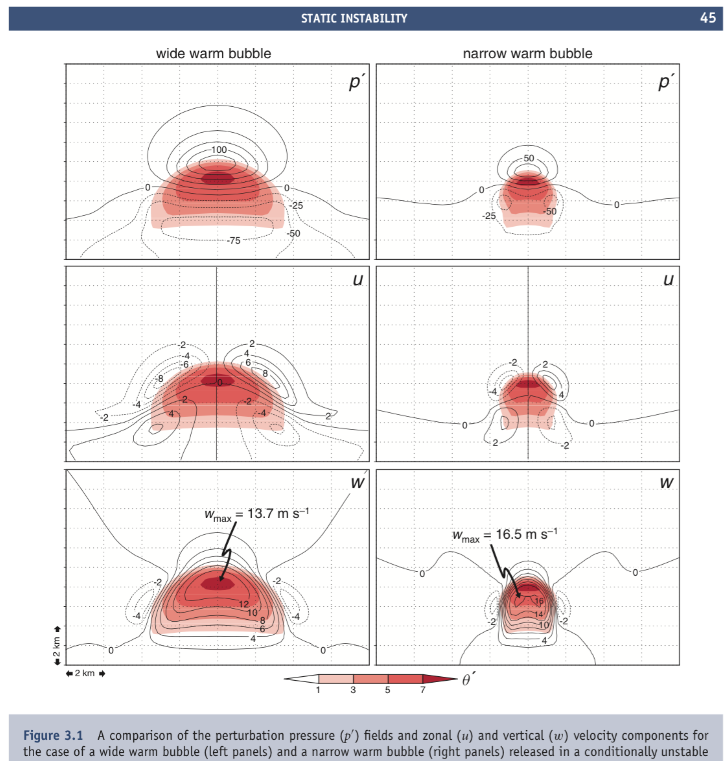

b. The buoyancy-driven pressure perturbation becomes greater as the horizontal scale of a buoyant region widens. What is the limit for a very wide feature? What does the vertical equation of motion (iv) in the equation set reduce to in that case?

18. Why are cumulus clouds bumpy? Explain.

Hint: Refer to this diagram (interpret it). Recall that the inverse Laplacian, the operation to get p’ from  acts sort of like a negative sign, as in the equation above. But it also acts as a smoothing operation, de-emphasizing spatially small features. For instance, as seen in Fig. 3.1 above, the upward acceleration of wide buoyancy features is more effectively opoposed by the p’ gradient force. The figure below shows the *net vertical acceleration* ( in our Boussinesq terms) in and around a block of positively buoyant air with bumps on top, in motionless air where all the advection and inertia effects (that is, the dynamic pressure terms) are zero.

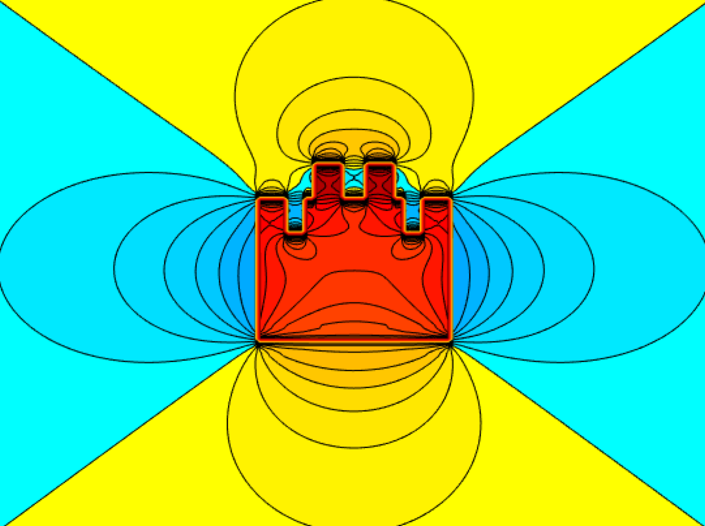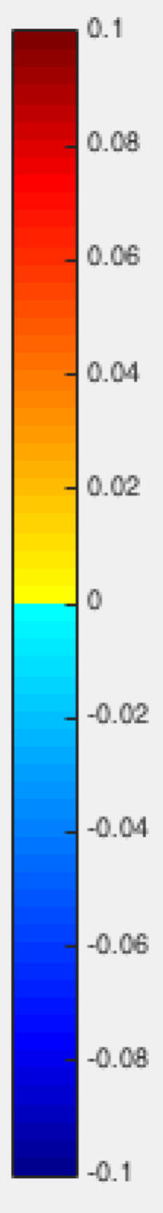

19. Explain the book cover, in terms of the horizontal and vertical components of the vorticity equation as given below.

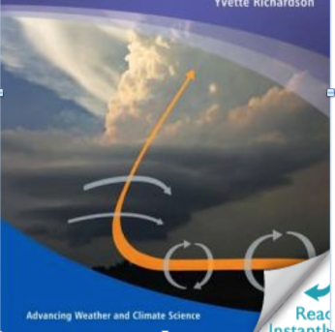

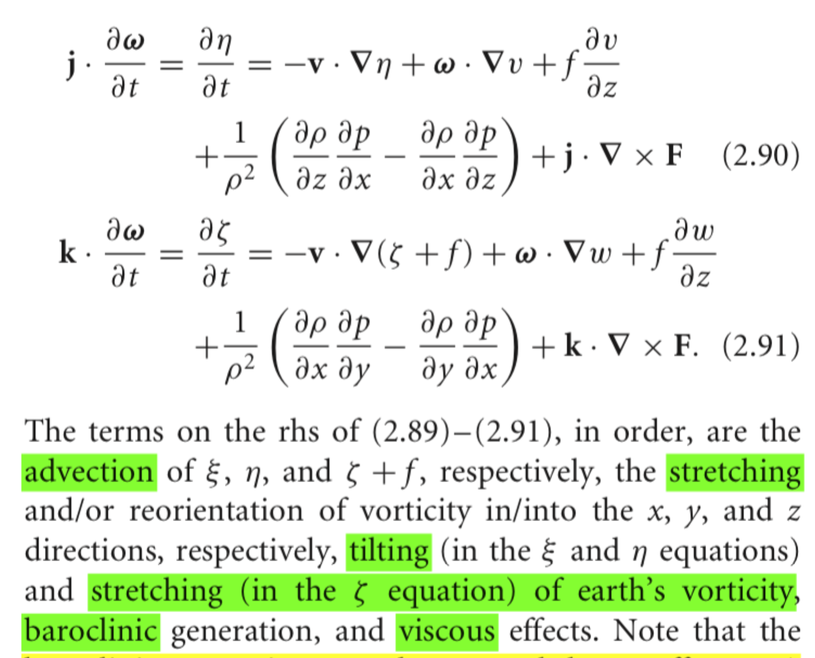

20. Tangential flow falls off as 1/r from a small element of vorticity, as shown here for the *positive vortex only* in this vortex pair.

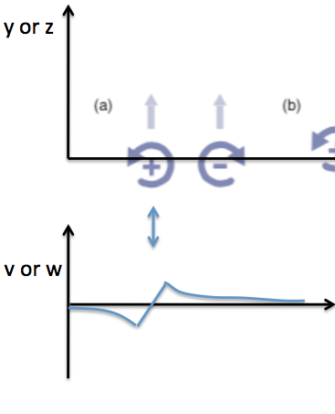

For each of the 4 twin-vortex cases below, make a similar sketch of the **total** v(x) wind profile along the axis of the vortices, **taking account of both vortices**, for the 4 vortex-pair cases below. Explain why the light gray arrows (indicating the total motion of the vortices), are indicated as they are.

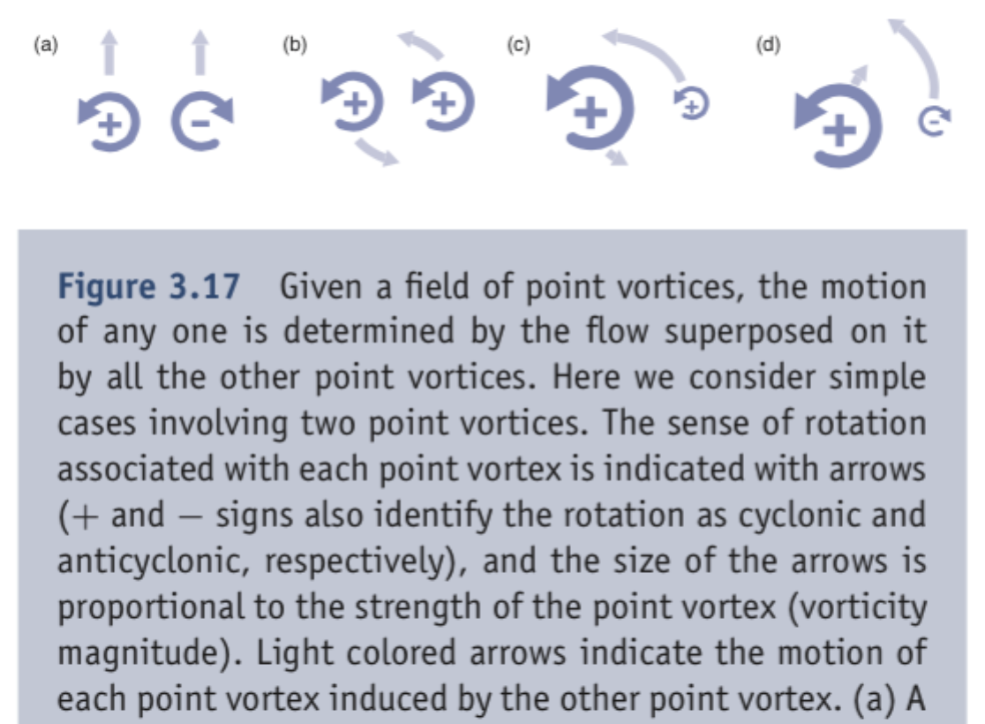

21. Study the diagram below (illustrating inflection point shear instability) well enough that you can explain it, if given the figure *without caption,* in the exam.

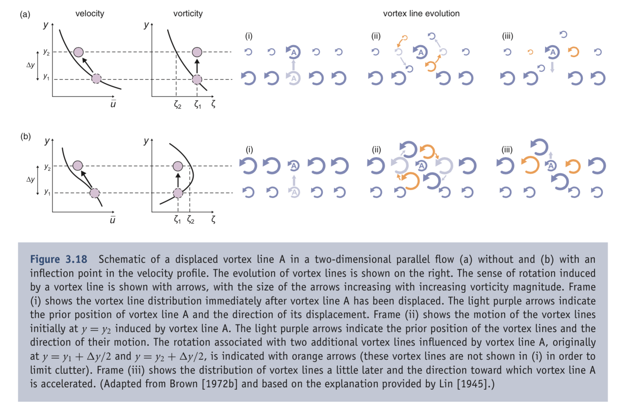

***22. Radar (Appendix A)***

1. What is the radar reflectivity Z? What are its units? What is dBZ, the decibel scale for Z?
2. How does radar reflectivity relate to the mass or volume of water in the set of raindrops suspended in a cubic meter of air?
3. How does reflectivity relate to the downward flux of rain water, if the terminal fallspeed of a drop depends on drop diameter as D3/2 (the ration of drop volume to drop surface area)?
4. Explain how polarimetric radar can help with
   1. QPE (quantitative precip estimation)
   2. hailstone detection
   3. debris detection
5. Why is there ambiguity (velocity folding) in the radial velocity, for Doppler radars that use simple pulse pair processing to sense returned-wave phase differences? Explain the source of the uncertainty.
6. Why is there range ambiguity and how does it rtrade off with Doppler velocity ambiguity in 5?
7. What kind of wind profile is indicated by each of these Doppler velocity signatures?

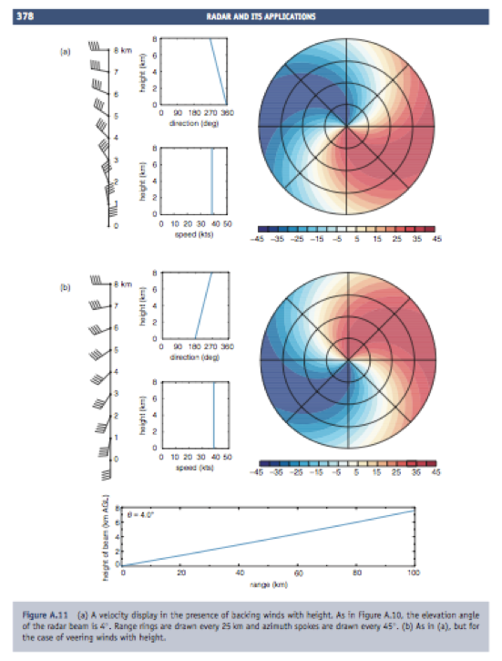

23. Why do supercells split? Explain what the caption explains about every feature shown.

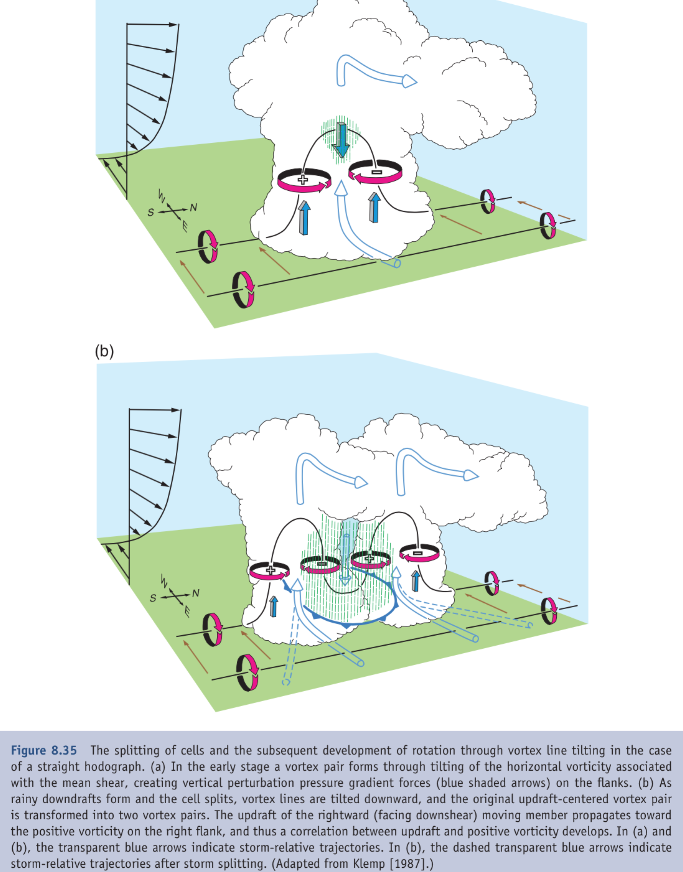

24. Why are right-moving storms favored over left movers, when there is streamwise vorticity or in other words, a turning hodograph or “helicity”?

Explain what the caption explains.

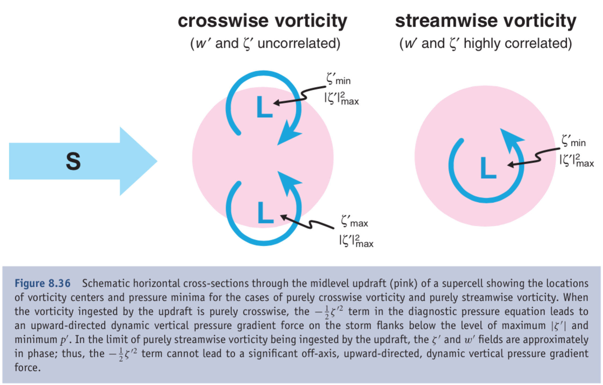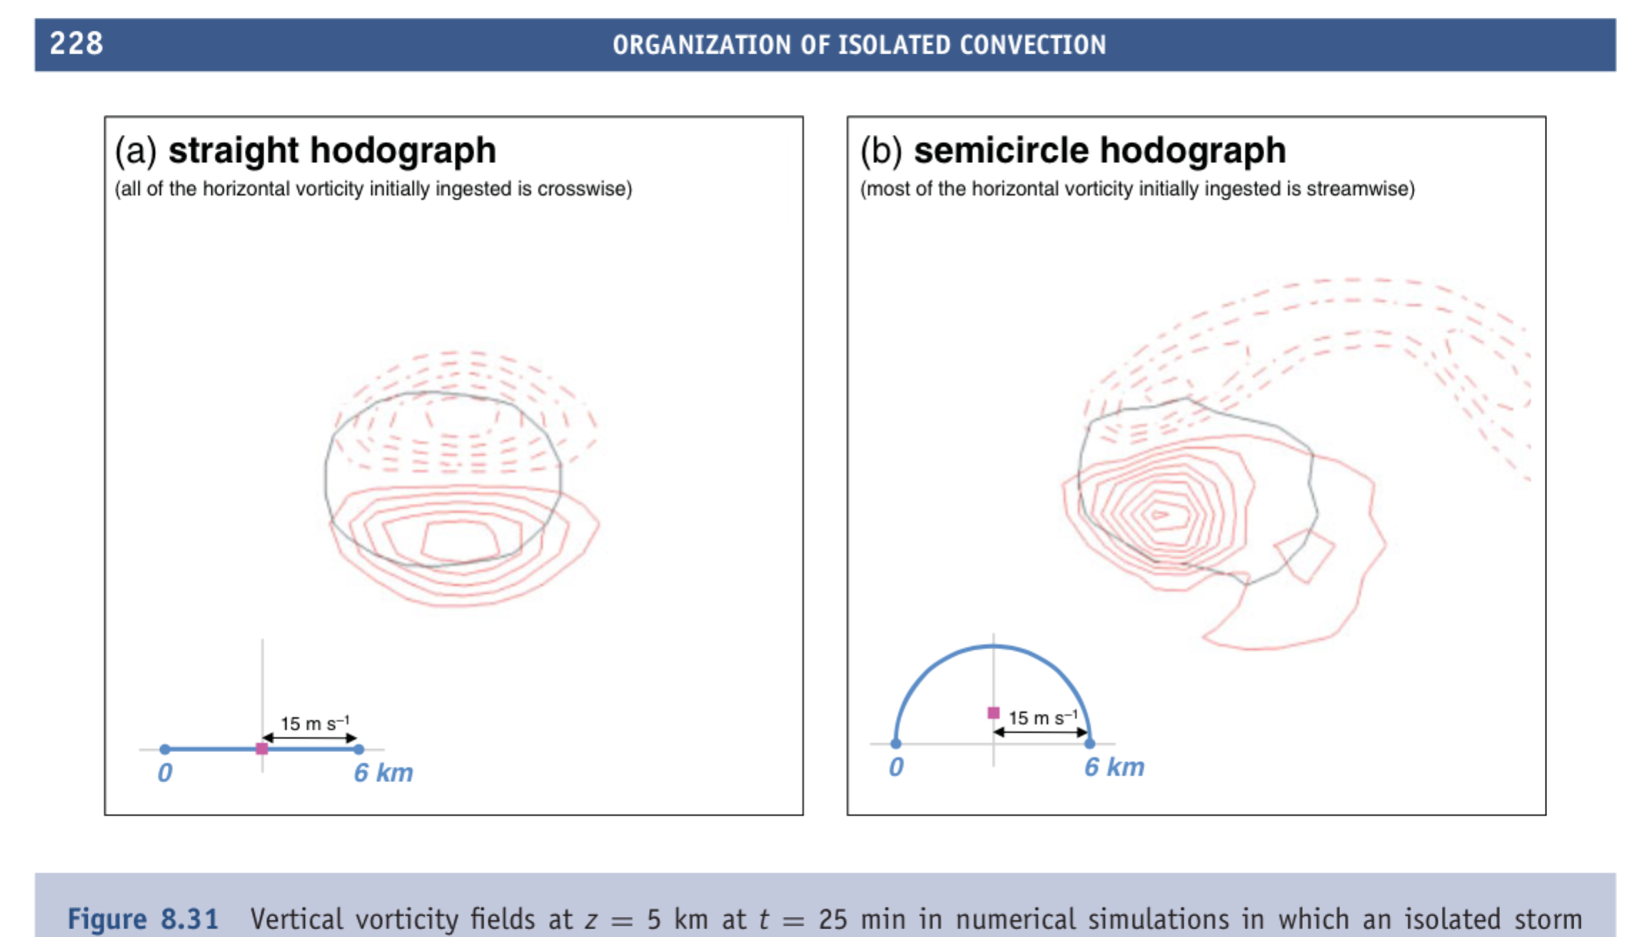

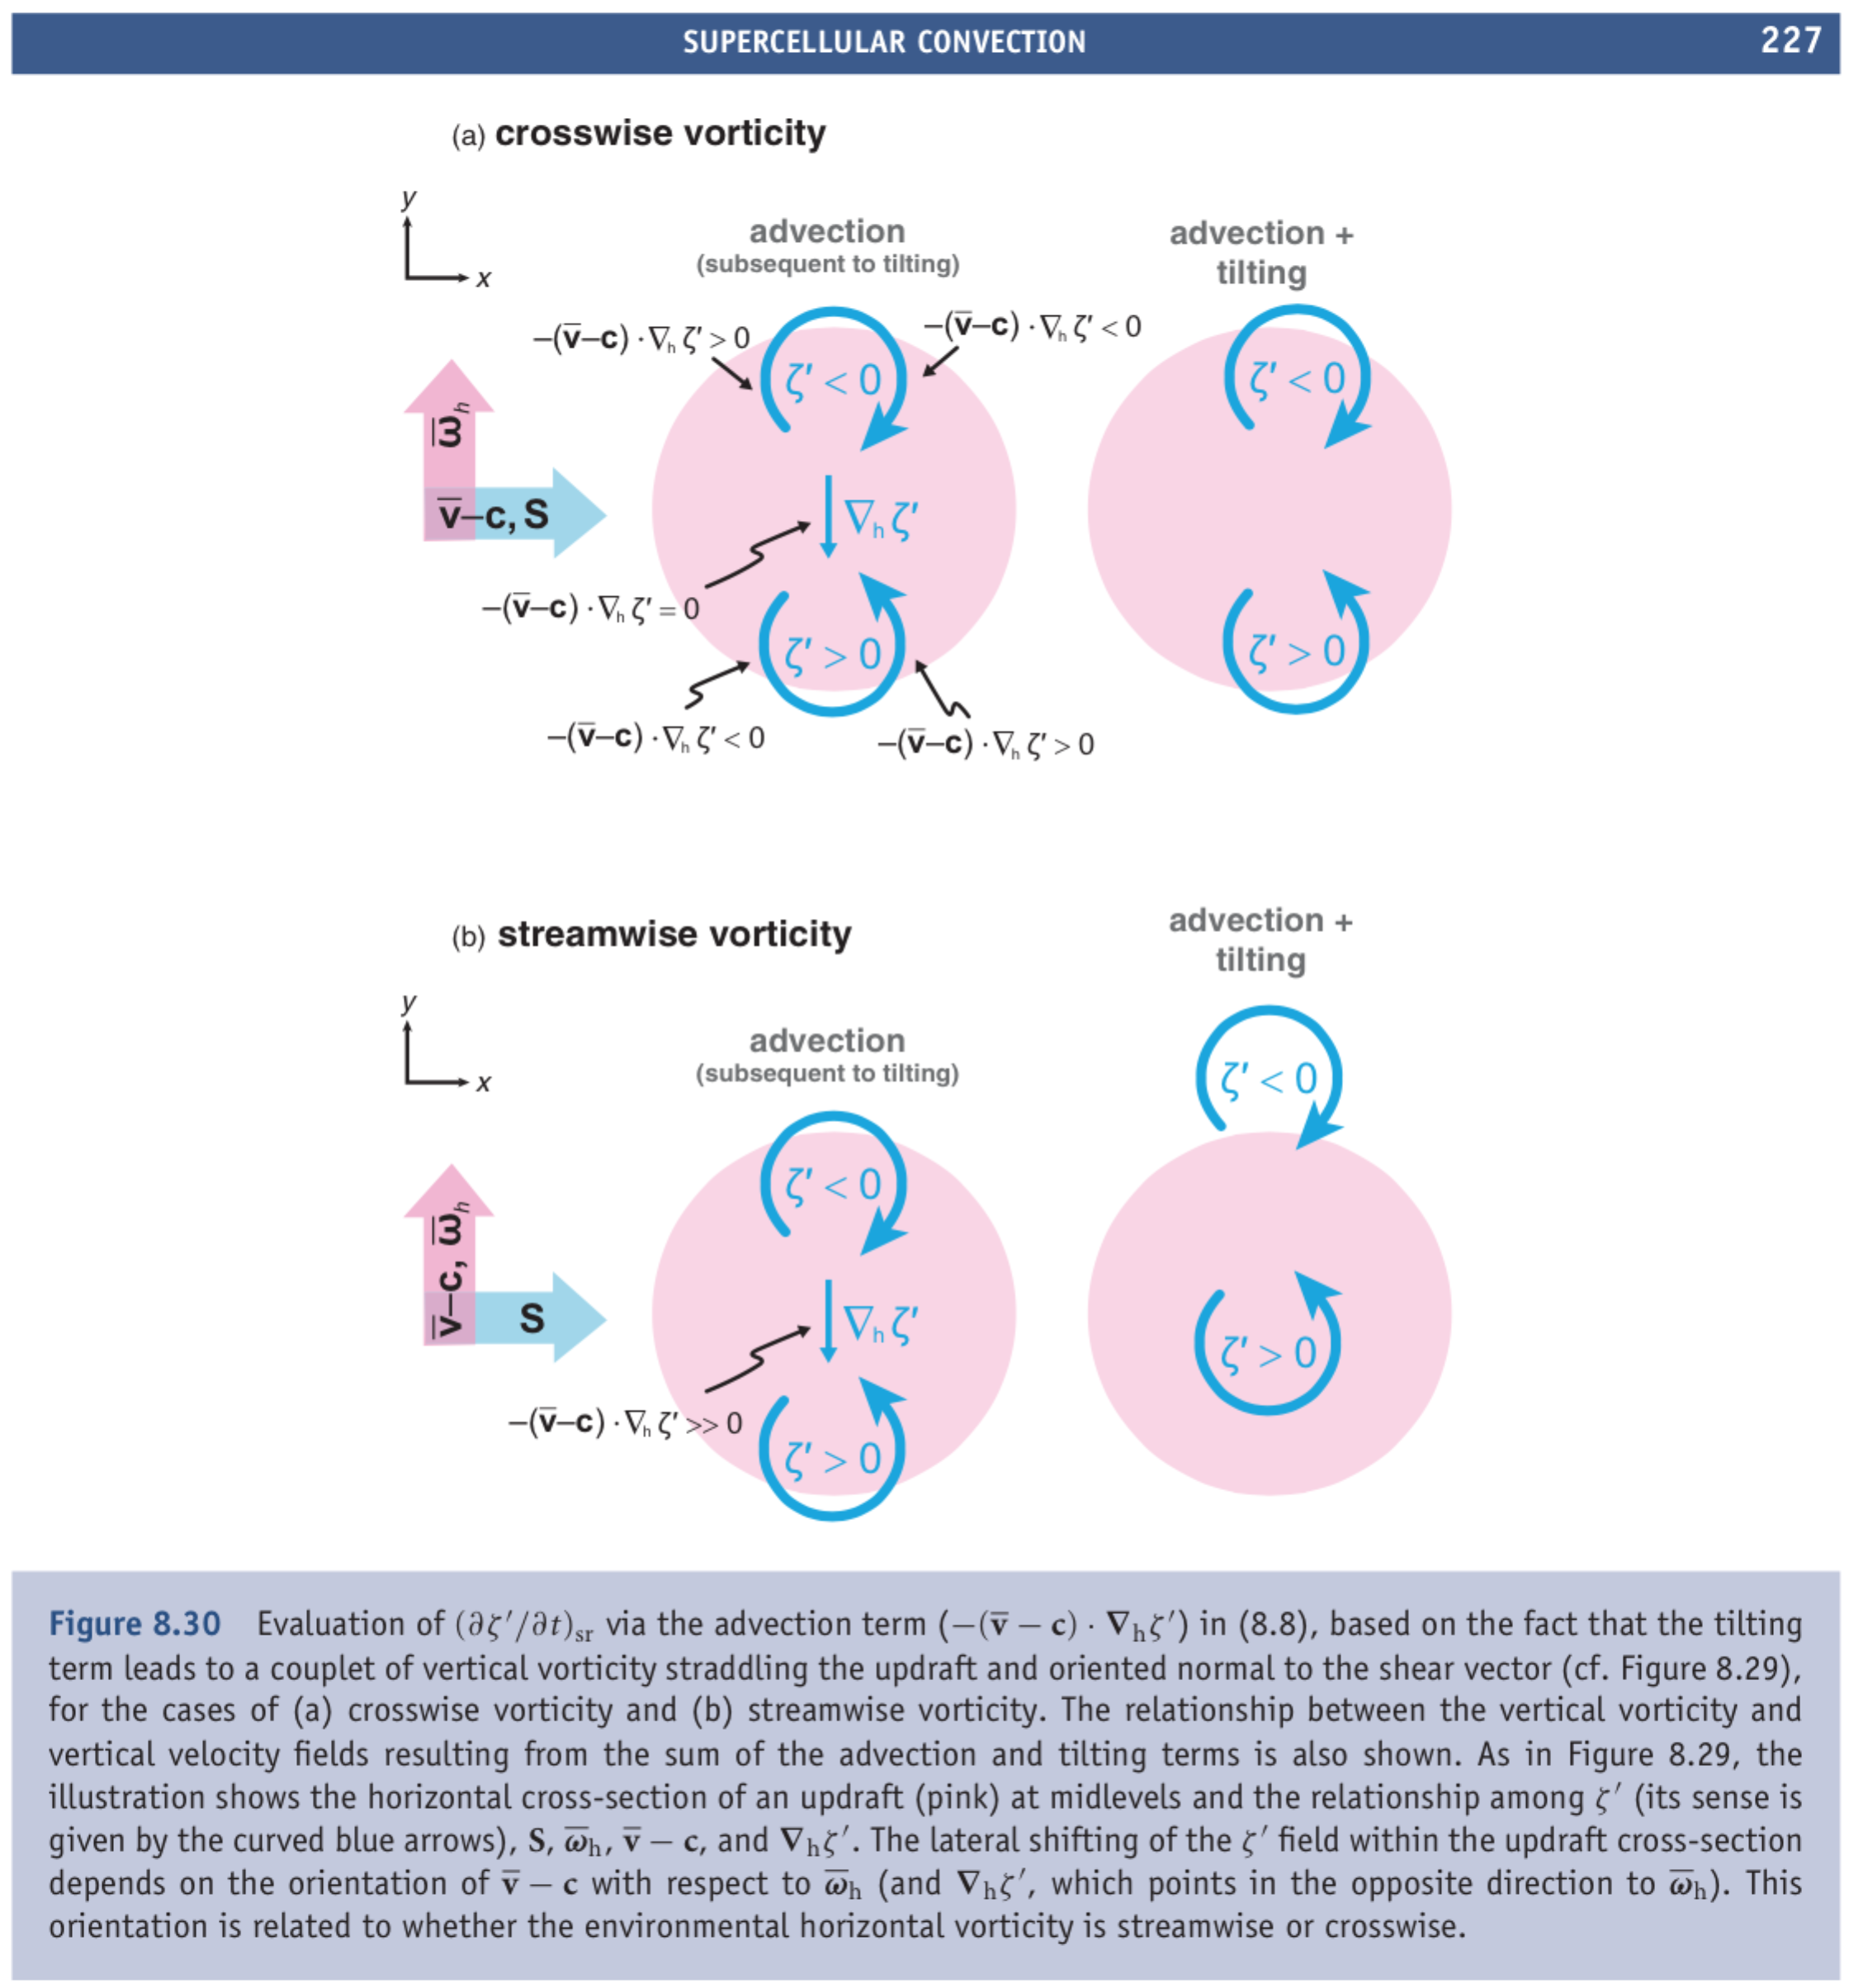

25. Explain how the Splat or “obstacle effect” term (the *linear term*, the book calls it) leads to the rear-flank downdraft. There is a high pressure perturbation p’ >0 where fast upper-level winds “hit” the tube of “slow air” brought up from lower levels by the updraft. In this case (book p219) it is at upper levels, and drives the rear-flank downdraft as well as parting the flow around the obstacle of the updraft tube. 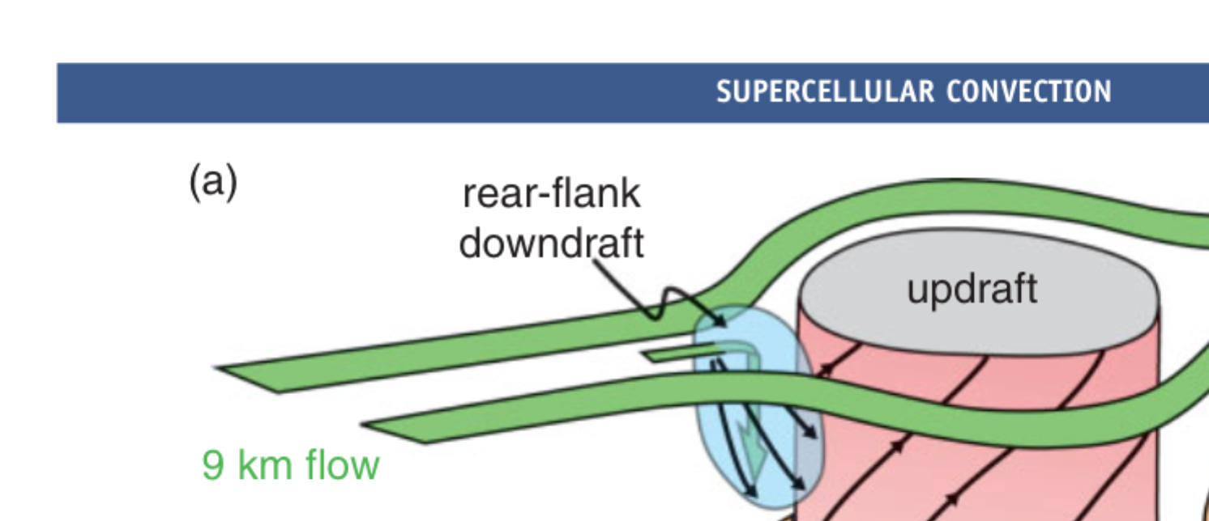

But this happens at every level, and the updraft air is not necessarily “slow”, it just has a slightly different vector momemtum (characteristic of a lower altitude in the wind profile). You can think of the shear vector S = upper-lower wind as the *relative* wind vector, the upper flow that that “hits” updraft air which came up with the momentum of a layer immediately below. Since 3D convergence\divergence is forbidden by mass continuity, a High pressure perturbation develops on the upshear side, where this relative wind is *con*vergent (*splat*). The H pushes air both horizontally and vertically to prevent genuine 3D convergence. A similar Low is created on the downshear side, where the updraft’s momentum is *di*vergent relative to the ambient wind.

